WFP Contributors Guide

Background
To ensure the success of our organization, we need to plan for our future. This plan includes a budget and forecast of where Vena will be in one year or five years.

One of the largest expenses that needs to be planned as accurately as possible is our workforce expenses which include salaries, bonuses, benefits, payroll taxes and more. As such, these expenses are budgeted for at the employee level to ensure they are as accurate as possible.

Prerequisites
Ensure that you have access to the following:
- Vena Access
- WFP Input Template – Where you will view and input data
- The ability to see HR Data within the input template
If you do not have access to the prerequisites, please contact the FP&A team.

A. WFP Input Template – Overview

Step 1  Login to V4V | Enter your OKTA ‘My Apps’ dashboard and click on the ‘Vena4Vena’ application.  Alternatively, go to https://vena.io/ and login using your Venacorp email address and password.
Step 2  Template | On the ribbon, enter the contributor tab.  Click into the input template named ’03 – WFP Input Template’.  When you enter the template, you will find three different tabs: Dashboard, Details and Summary.
Step 3  Template Overview | The dashboard enables users to review the main HR KPIs related to specific department(s).  The details tab enables users to save data at the employee level as well as override existing forecasted data. In addition, contributors can also forecast future employees with or without a requisition request while also capturing upcoming employee transfers.  The summary tab enables contributors to review a summary of the main labour expenses related to specific department(s). If you would like to review a specific aggregated number, enter the ribbon and click drill > drill down.  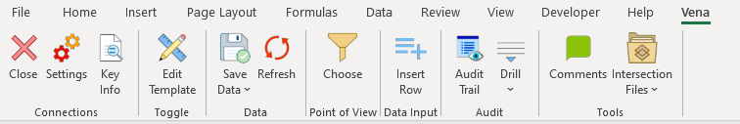
Step 4  Details Input Tab | Enter the details input tab.  Within the details tab, you will see three sections: existing employees, future employees, and upcoming employee transfers.  - Existing employees – These are the existing employees within Vena with their details loaded in from ADP. Refer to section B. WFP Input Template – Existing Employee.  - Future employees – These are the future employees that you would like to hire into the department. Refer to C. WFP Input Template – Future Employee on how to add a future employee.  - Upcoming employee transfers – These are the upcoming employee transfers into your specific department from another department that have been detected. For example, an employee has transferred from department 64 to 65 within the period. Refer to D. WFP Input Template – Upcoming Employee Transfers on how to add a future employee.
Step 5  Cell References | Each cell is colour-coded for different reasons:  - Blue cells = direct input  - Grey Cells = calculation  - White cells = data retrieve (from the cube)

B. WFP Input Template – Existing Employee

Step 6  Checks & Overrides | For existing employees, ensure that everyone in your department is accurately represented and all details are correct (i.e. hire date, salary, termination dates, etc.)  If they are not correct, there are override columns to adjust these details. For example, if the termination date is incorrect, ensure that you adjust it to reflect the correct end date in the blue input cell.  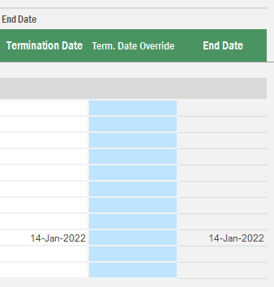
Step 7  Leaves | If there are any temporary leaves (parental leave, stress leaves, etc.) ensure that you input a leave date and a return date in the blue cells.  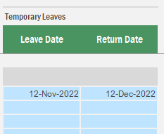
Step 8  Transfers | If there is a transfer to a different entity and/or department, you will need to input this into the transfer section of the template.  Ensure you put a relevant transfer out date in DD-MM-YYYY format.  Ensure that you select the correct transfer to entity in the dropdown.  Ensure that you select the correct transfer to department in the dropdown.  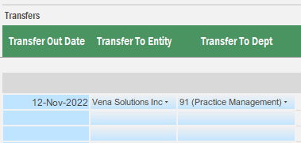  If there is a transfer in from another department, it will show up in the next set of columns automatically.
Step 9  Inputs & Benefits | To input employee benefits, there will be a variety of drivers present to offer flexibility.  - Eligibility – Determine whether each employee is eligible for a specific benefit.  - Driver amount ($) – Input the fixed dollar value  - Driver amount (%) – input the percentage value.  For annual bonus, the driver can either be a dollar ($) value or a percentage. Please only use the single column required.
Step 10  Save Data | You can review the line-by-line details based on your inputs from columns DT (headcount) onwards.  When you feel satisfied with what you have inputted, go to the ribbon, and click ‘save data’.

C. WFP Input Template – Future Employee

Step 11  Insert Row | To add a future employee, you will need to select the cell that states ‘click insert row in Vena ribbon.  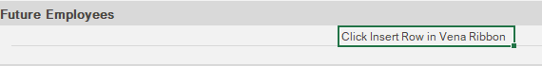
Step 12  Insert Row | Navigate to the vena ribbon and select ‘Insert Row’.
Step 13  Create future employee | A choose box will appear. Select the combination of department, entity, employee, and workers category for your future employee.  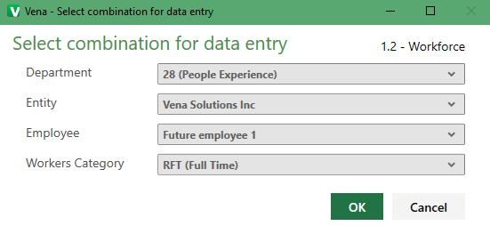
Step 14  Input details | An additional row will appear based on your selection. Now, you can input the future employee details in the blue direct input cells.
Step 15  Save Data | You can review the line-by-line details based on your inputs from columns DT (headcount) onwards.  When you feel satisfied with what you have inputted, go to the ribbon, and click ‘save data’.

D. WFP Input Template – Upcoming Employee Transfers
Step 16  Overview | The WFP input template can capture upcoming employee transfers. This is done by comparing the previous period HR load to the current period HR load.  For example, if an employee was in department 120 in the January load but, then was in department 140 in the February load. They would be captured in the upcoming employee transfers section with a January 15th estimated transfer date.  The upcoming employee transfers section captures these employees to highlight them for the contributor.
Step 17  Editing Details | You will notice that upcoming employee transfers will show up in the existing employee section and the upcoming employee transfer section.  If you would like to adjust the details for these employees, this can be done in the existing employee section.

